Experiment 1 – DSP Lab

Mohadeseh Azari, 810196404

- Part One
In this part we want to implement FIR filter using Matlab.
Applying filter using convolution:

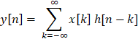

Using Z transform of FIR filter we get:

Implementing FIR filter using Matlab:
First we read the ‘mefsin.wav’ file which returns y & sampling rate. If we use sound command, we would hear that there are various noises within the initial file.

After that we plot signal’s Fourier transform to see the frequency distribution over [0, Fs/2].

This is the result of single sided amplitude spectrum of ‘mefsin.wav’:

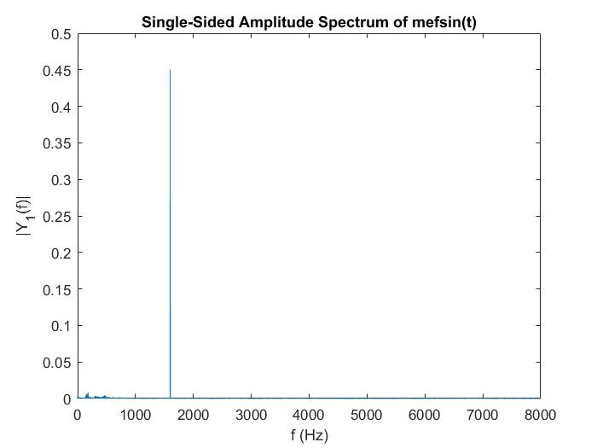
Spectrum of mefsin.wav

Filtering part:
Now we have to build a FIR filter in order to filter out the noise. As we saw earlier

So by placing zero near noise frequency, the noise will be omitted.

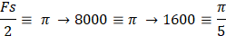

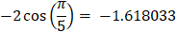

After defining the coefficients of the filter we could use filter function in Matlab to filter out the noisy file.

The spectrum of noiseless file is as followed:

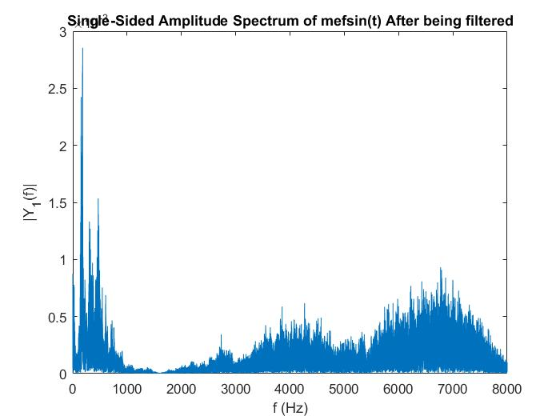
After being filtered

- Part 2
In this part the signal should be filtered using circular buffer in C language.

First, using fdatool, design the filter with given parameters,
Here is the result of fdatool:

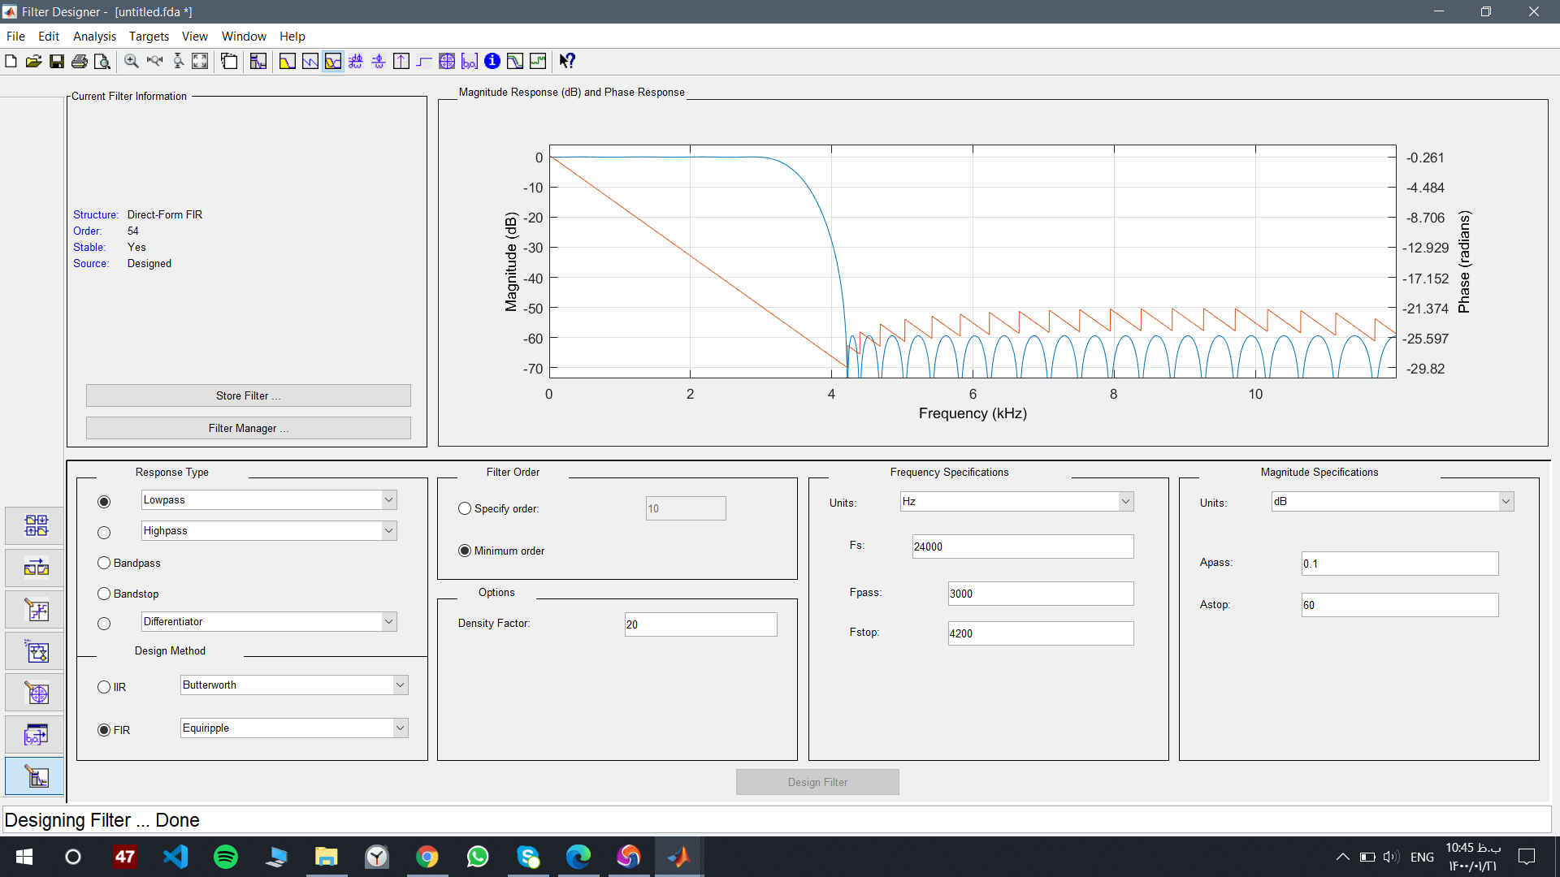
FRI filter using fdatool, Matlab

After building the filter in fdatool we have to extract in into Matlab workspace. Two ways mentioned in Lab manual which I used the first way, and copy the coefficients of h[n].

Implementing the filter in C language

The overall code of circular filter is in again in Lab manual
And I just made some brief changes in case of reading
‘sine.txt’ file and printing the output to ‘sine_out.txt’.

‘sine.txt’ is a result of Matlab code. There are two different categories:
- Sine wave without noise
- Sine wave with white noise

Here are the input.txt file before being filtered:

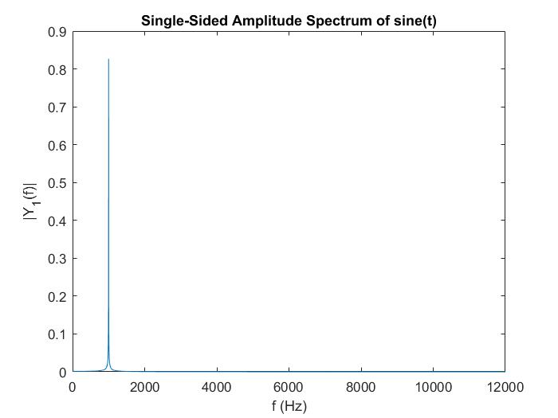
Sine Wave without noise with frequency 1500Hz

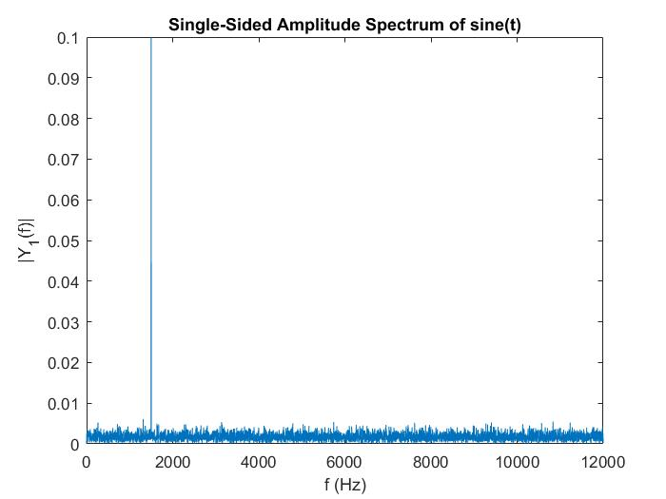
Sine wave with white noise with frequency 1500Hz

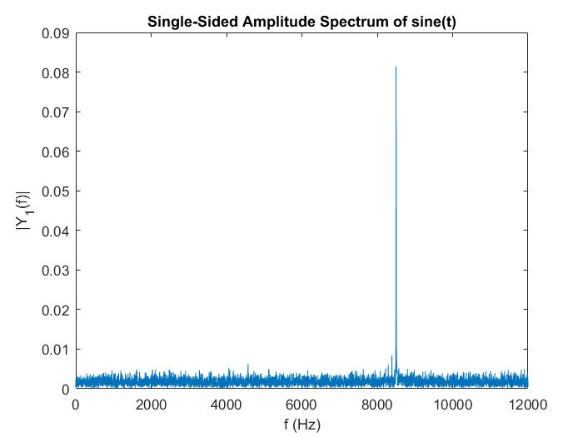
Sine wave with white noise with frequency 8500Hz

After running main.c , main.o will generate another textfile which is after being filtered. Using fft function in Matlab, it is nocible that after about 4200Hz that is fpass, the signal is completely filtered.

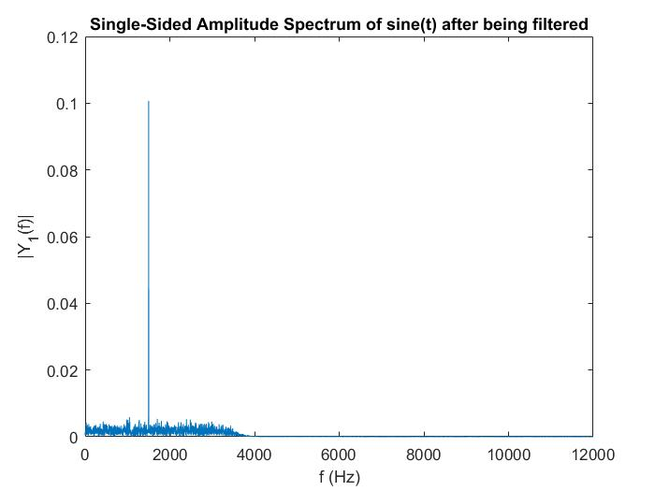
Sine wave with frequency 1500Hz

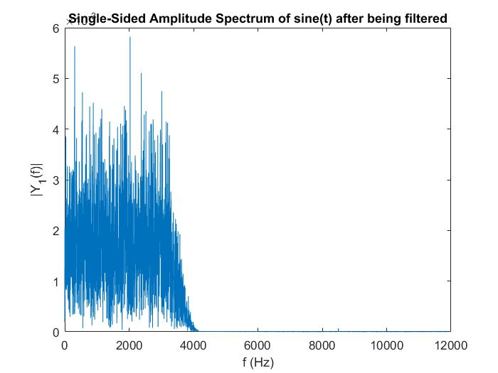
Sine wave with frequency 8500Hz

